## Tester: Phạm Tuấn Kiệt, Trịnh Huỳnh Đức

## User: Student

Goal: Students can upload, edit and comment articles into the system. He/She can also be limited to do it before a certain closure date that they can see

Triggers: User login using the Student account

Preconditions: Student account must exist in the database and accessible.

## Test case:

This is the login page and students enter the email information and password they have created to log in to the school's profile page.

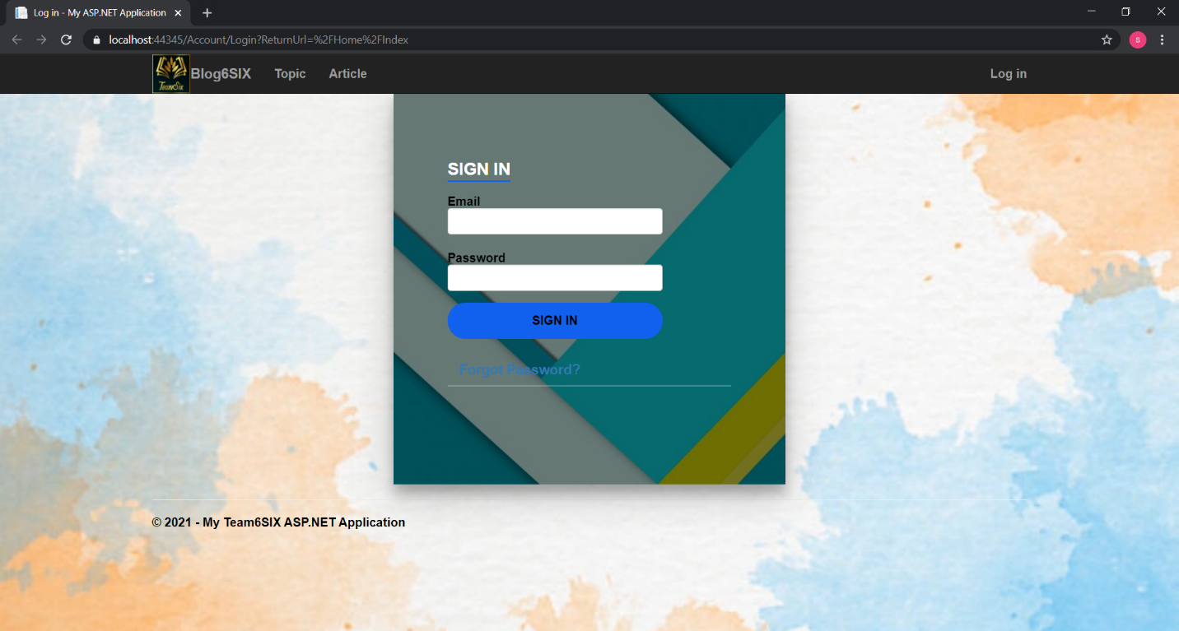

After successfully logging in, students will see the Home Page with the words "Welcome student01@gmail.com!" to confirm access to the student site. And there are 2 categories of Article Add and My Article. And students can log out using the Log off button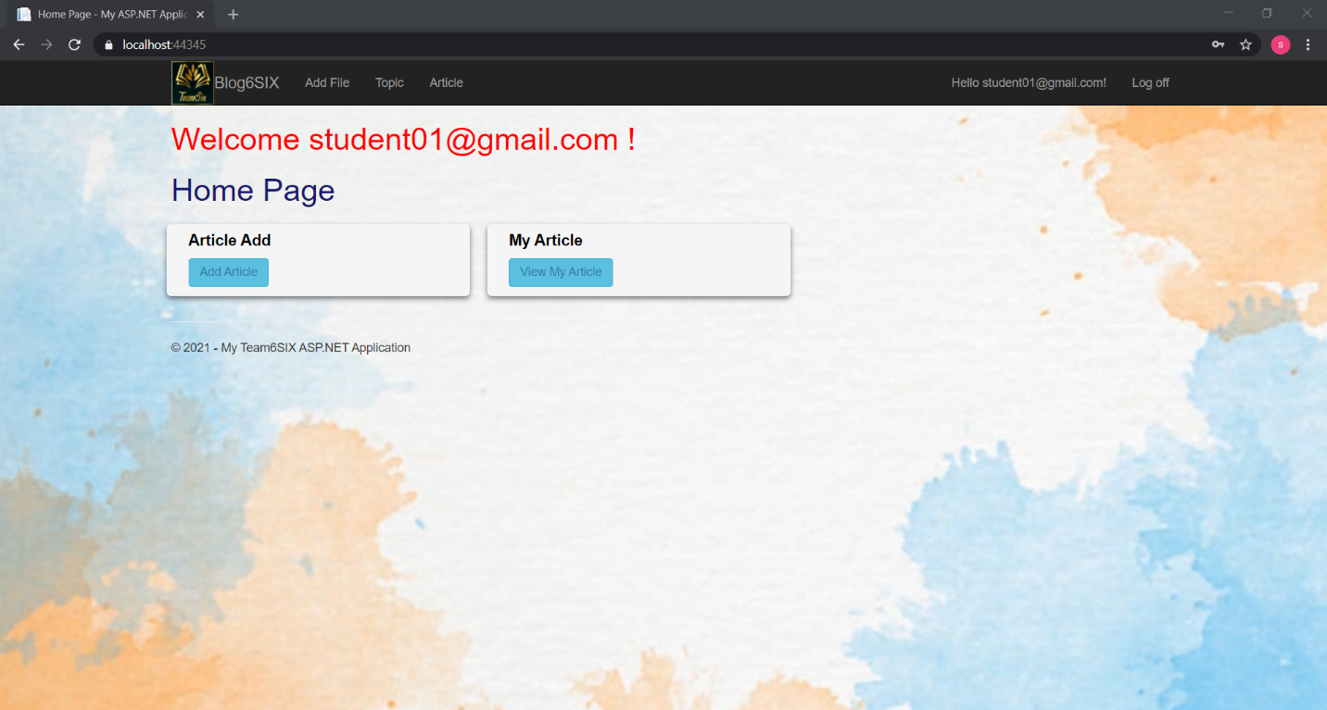

About Article Add page is the function that students create and submit articles and include the following conditions. The first line will show which student the article was created by and enter the school's email to confirm. Next is the title of the article, the students write down the title of the article they have written about. Then choose the topic of the article already vieesty. As for Article Post Date, which is the date when students submit their articles, the submission time will be clearly shown. Finally the function of uploading articles to the web to submit in doc format

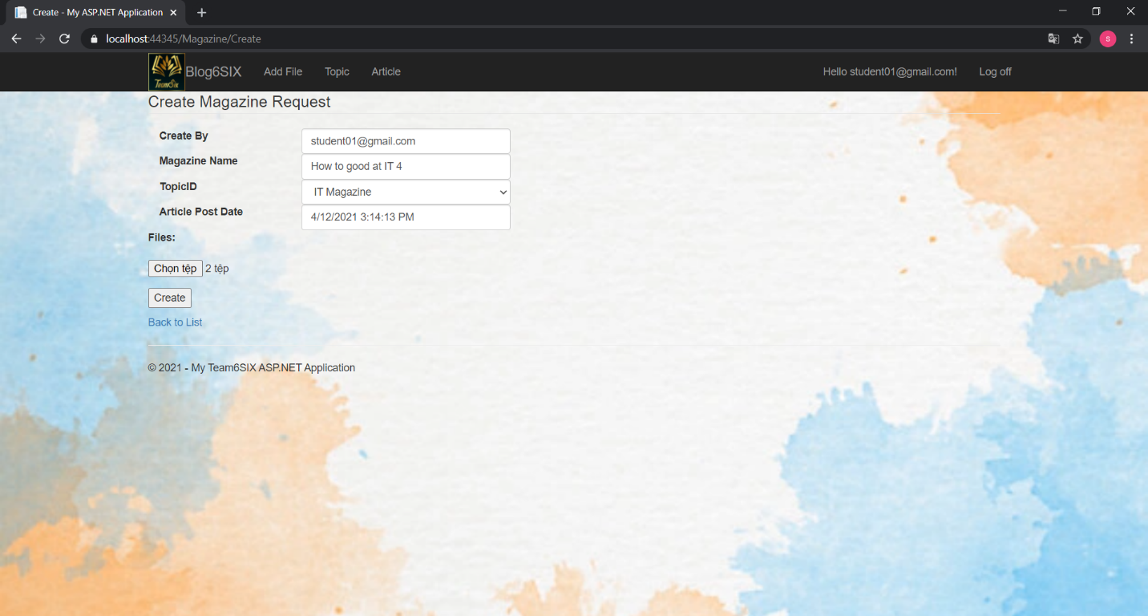

As for My Article Page, this is the function where students can view their updated articles on the website and can edit or remove the created articles. Students can edit the title of the article, the subject title and the uploaded article. When this article is found inappropriate, students can delete the article by clicking the delete button and clicking OK to confirm the deletion of the article.

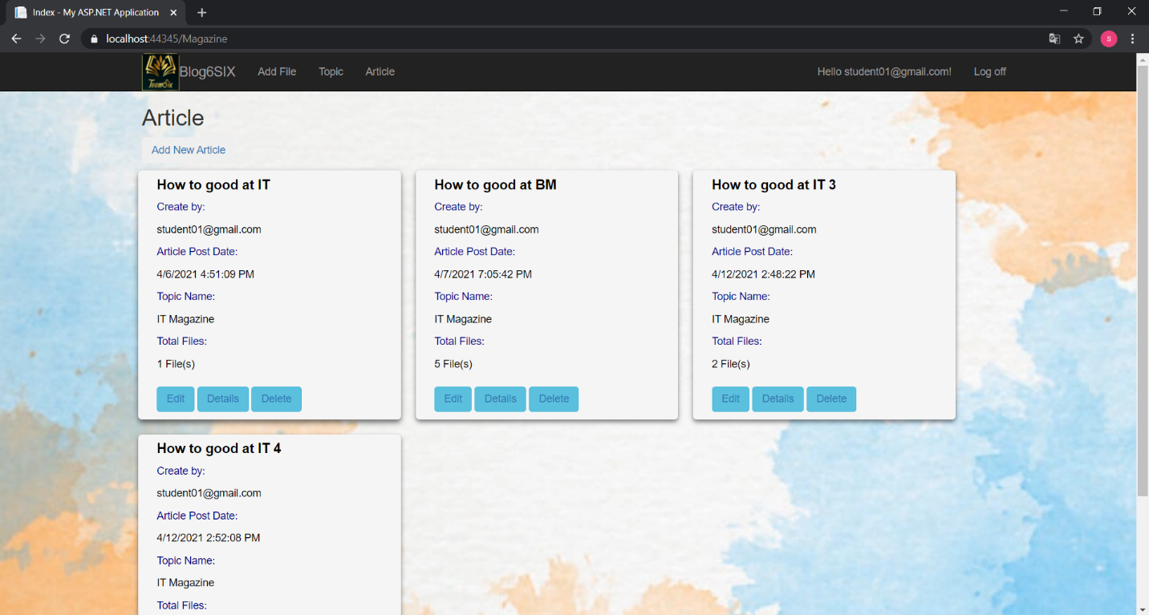

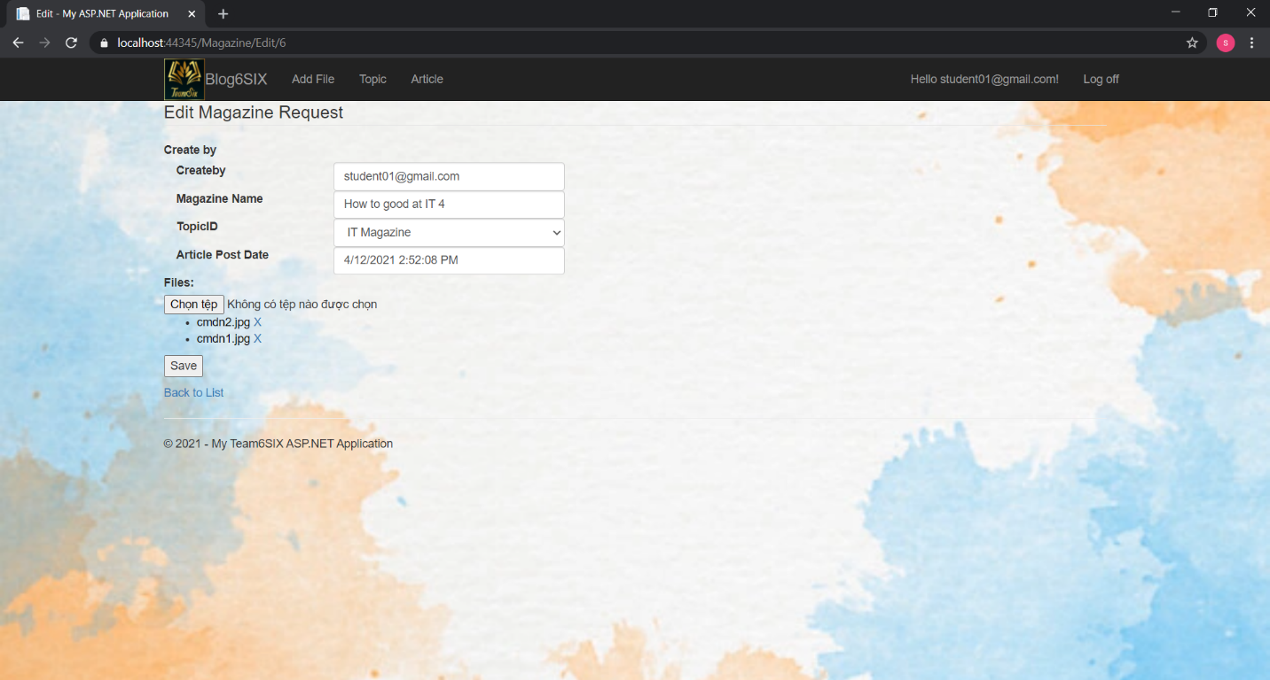

Students can edit the title of the article, the subject title and the uploaded article. When this article is found inappropriate, students can delete the article by clicking the delete button and clicking OK to confirm the deletion of the article. After confirming the article will no longer appear on the My Article page.

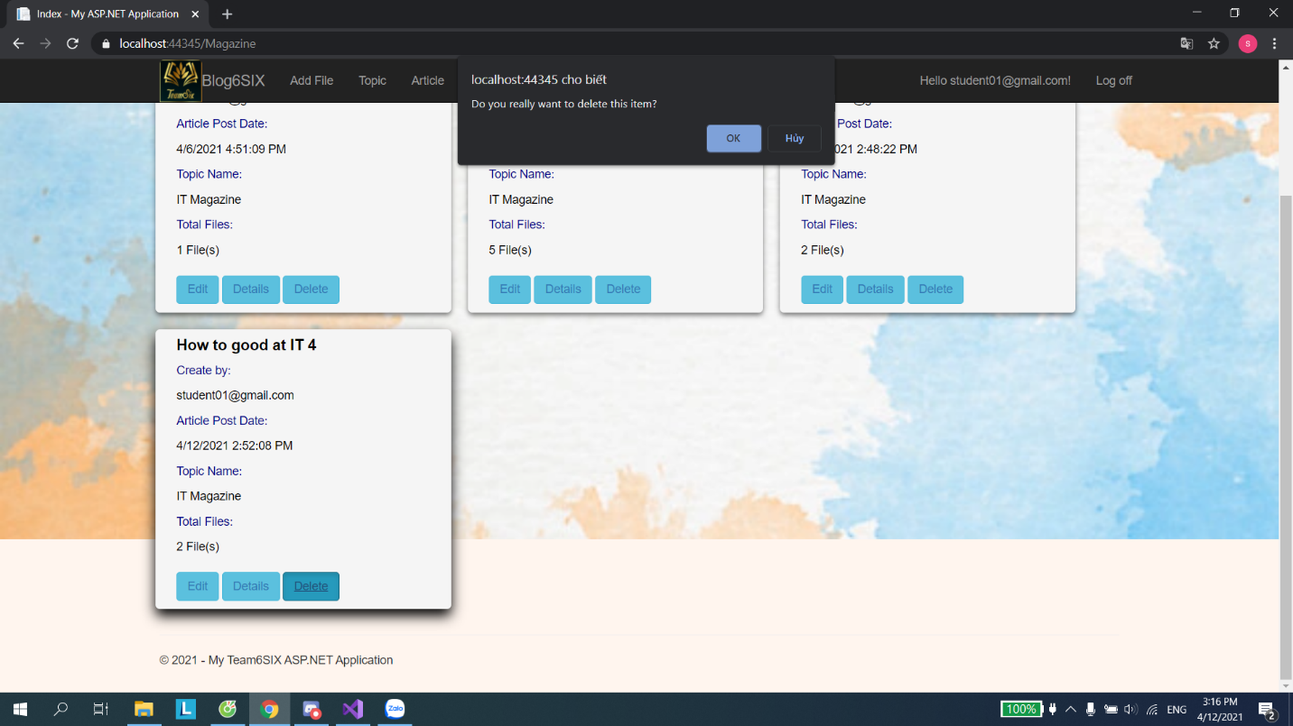

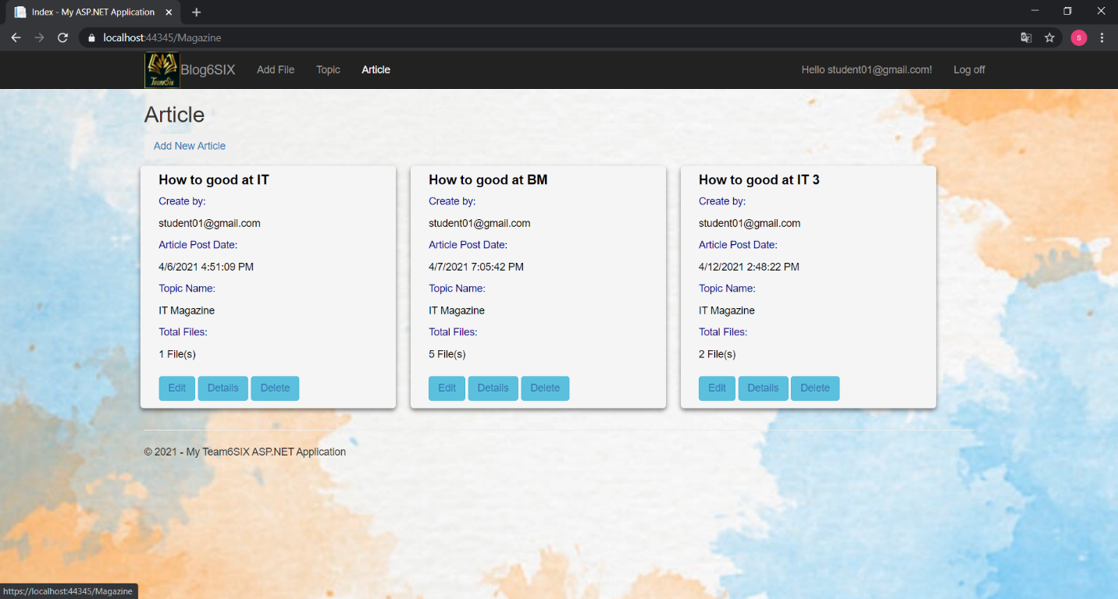

|  |  |  |  |  |  |
| --- | --- | --- | --- | --- | --- |
| **Functions** | **Test Scenario** | **Step Description** | **Expected Result** | **Actual Result** | **Status** |
| Test if Student can logon | Student can logon into the system using their accounts | 1) Enter the Login page 2) Input Student’s username and password | Student should be login into the system and redirected back to the Home page | Successful | Pass |
| Test if Student can see other student’s articles | Student can’t see other student’s articles | 1) Login using a Student account 2) View the Home page  3) Select View Articles | Student should only see the articles that they created | Successful | Pass |
| Test if Student can upload an article | Student can upload an article into the system | 1) Login using a Student account 2) View the Home page  3) Select Add Articles  4) Fill in all the blanks and upload a file into the fields  5) Click submit | The newly created article should be saved into the database and displayed in the View page | Successful | Pass |
| Test if Student can edit an article | Student can edit an existed article in the system | 1) Login using a Student account 2) View the Home page  3) Select View Articles  4) Select an existed article  5) Click edit | The student should be put back to the create article page with all the info that the existing article fill in to edit | Successful | Pass |
| Test if Student can delete an article | Student can delete an existed article in the system | 1) Login using a Student account 2) View the Home page  3) Select View Articles  4) Select an existed article  5) Click delete | The article should be deleted from the database and doesn’t display in the View page | Successful | Pass |
| Test if Student can see their profiles | Student can see their information in the profile page | 1) Login using a Student account 2) View the Home page  3) Select their name | The profile page should be displayed with their information | Nothing | Fail |
| Test if Student can change their password | Student can change their account’s password to their liking | 1) Login using a Student account 2) View the Home page  3) Select their name | The new password should be saved into the database and return back to the Main page | Successful | Pass |
| Test if Student agree to Terms and Conditions before submitting | Student needs to agree to the terms and conditions before allowing to click the submit button | 1) Login using a Student account 2) View the Home page  3) Select Add Articles  4) Fill in all the blanks and upload a file into the fields  5) Click “I have agreed to the terms and conditions”  6) Click submit | The submit button should be enable when the Student tick the terms and conditions. | Nothing | Fail |
| Test if Student can see comments in an article | Student can see comments in an article | 1) Login using a Student account 2) View the Home page  3) Select View Articles  4) Select an existed article  5) Click view | The comment section should be visible to the Student | Successful | Pass |
| Test if Student can comment an article | Student can comment an article | 1) Login using a Student account 2) View the Home page  3) Select View Articles  4) Select an existed article  5) Click view  6) Write comment in the comment section | The newly created comment should be saved and displayed afterwards | Successful | Pass |